Appendix C: IEEE 830 Template
Software Requirements Specification
for
Your Path

Version v2.1
Prepared by Mustafa Cilek
14/04/2026
Table of Contents
«Table of Contents»
Revision History
Name | Date | Reason for Changes | Version
Mustafa Cilek | 04/03/2026 | ”Initial version” | V1
Mustafa Cilek | 25/03/2026 | ”Added UML Use Case Ciagrams” | V1.1
Mustafa Cilek | 07/04/2026 | “Added UML Class Diagrams” | V2
Mustafa Cilek | 14/04/2026 | “Fixed Use Case and Class Diagrams and added descriptions. Completed Introduction.” | V2.1

1. Introduction
1.1. Purpose
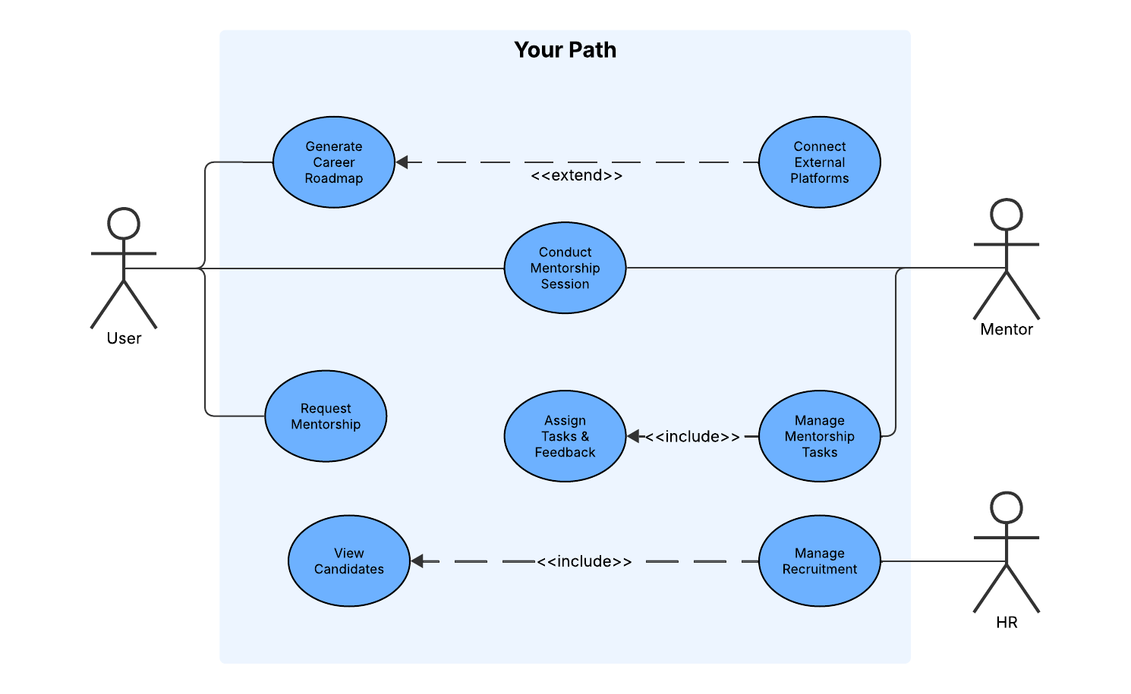
The purpose of this project is to solve a huge problem in today’s job market: students often don't know how their skills fit into the current job market, and recruiters struggle to find verified proof of what a candidate can do. Your Path solves this problem by combining AI-generated career paths with a proper mentorship program. Instead of relying on generic advice that has no relation with the personal data, users get clear, data-driven guidance. At the same time, HR professionals get a hiring platform filled with candidates whose skills are backed and verified by experienced mentors.
To show exactly how people will interact with the platform, this version of the report includes a UML Use Case Diagram. The diagram shows the workflows for our three main actors:
- User (Student/Candidate): They use the app to generate their roadmap, request mentorship, and join sessions. The diagram uses an <<extend>> relationship to show that users can optionally link external accounts (like LinkedIn or GitHub) to get a better, more personalized AI roadmap.
- Mentor: They run the mentorship sessions. The diagram uses an <<include>> relationship to show that managing a mentorship requires the mentor to assign tasks and give feedback.
- HR: They use the platform to manage their hiring.
Overall, the UML use case diagram gives a clear summary of what the system does and how the different users interact with the app.
1.2. Document Conventions
To keep this document easy to read and track, I've used a few simple formatting rules:
Text Styles:
- Bold text: Used for the main system actors (like User, Mentor, HR) and core features.
- Italic text: Used for outside platforms we connect to, like LinkedIn or GitHub.
- Code text: Used for exact UML terms (like <<extend>> and <<include>>).
Requirement Tags: To make things easy for the developers to track, every requirement has a short ID:
- FR-XX: Functional Requirements (e.g., FR-01).
- NF-X.X: Nonfunctional Requirements. The first number is the category (like 1 for speed, 2 for security), and the second is the exact rule (e.g., NF-1.1).
1.3. Intended Audience and Reading Suggestions
This document is written for the development team, QA testers, project managers, and key stakeholders involved in building the Your Path platform.
Here is how the document is laid out and the best way to read it depending on your role:
- Project Managers & Stakeholders: Start with Section 1 (Introduction) and Section 2 (Overall Description). These sections explain the big picture, the core goals, and the user workflows without getting bogged down in technical details.
- Developers & QA Testers: You will need to read the entire document, but your main focus should be on Section 4 (External Interfaces), Section 5 (System Features), and Section 6 (Nonfunctional Requirements). These sections contain the exact rules, constraints, and data structures you need to build and test the software.
It is best to read the document straight through. The high-level diagrams and descriptions in the first few sections will give you the context you need to understand the detailed technical requirements later on.
1.4. Product Scope
Your Path is a web-based platform that combines AI-driven career planning with expert mentorship. Its main goal is to help students figure out exactly what skills they need to land a job, while giving companies a reliable way to find verified talent.
The primary objectives of the system are:
- Personalized Guidance: Generate custom learning roadmaps using AI, based on a user's current skills and linked profiles (like GitHub or LinkedIn).
- Mentorship & Verification: Connect users with industry professionals who can assign tasks, provide feedback, and officially vouch for their abilities.
- Streamlined Hiring: Give HR teams access to a pool of candidates whose skills have been actively vetted by mentors, reducing the risk of bad hires.
From a business perspective, Your Path aims to fix the broken early-career recruitment pipeline. By acting as a bridge between academic learning and industry expectations, the platform reduces hiring costs for companies and accelerates career growth for students.
1.5. References
The following documents and standards were used as a foundation for this specification:
- IEEE Std 830-1998: IEEE Recommended Practice for Software Requirements Specifications.
- Course Assignment: Software Engineering Laboratory Assignment Guidelines, Lodz University of Technology, Spring 2026.
- UML Standard: Object Management Group (OMG) Unified Modeling Language Specification, Version 2.5.1 (used as the standard for the Use Case and Class diagrams).

2. Overall Description
2.1. Product Perspective
«Describe the context and origin of the product being specified in this specification. For example, state whether this product is a follow-on member of a product family, a replacement for certain existing systems, or a new, self-contained product.»
2.2. Product Features
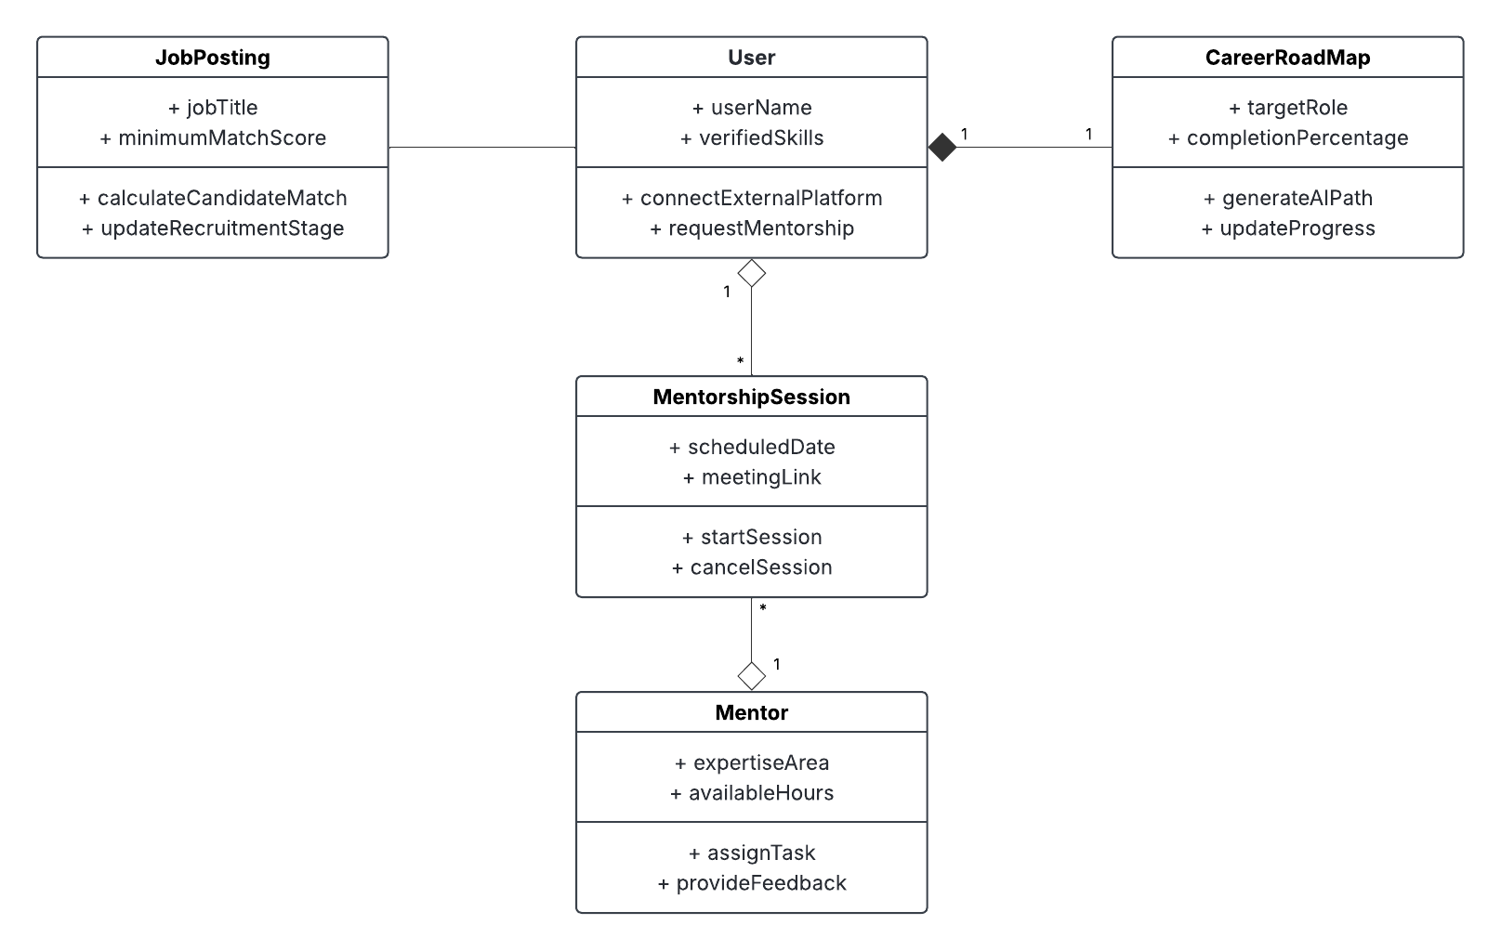

«Summarize the major features the product must perform or must let the user perform. Details will be provided in Section 3, so only a bullet list is needed here. Organize the features to make them understandable to any reader of the specification. A picture of the major groups of related requirements and how they relate, such as a top level data flow diagram or object class diagram, is often effective.»
- «Thing 1»
- «More things as required»
2.3. User Classes and Characteristics
«Identify the various user classes (intended target for the product) that you anticipate will use this product. User classes may be differentiated based on frequency of use, subset of product functions used, technical expertise, security or privilege levels, educational level, or experience. Describe the pertinent characteristics of each user class. Certain requirements may pertain only to certain user classes. Distinguish the most important user classes for this product from those who are less important to satisfy.»
2.4. Operating Environment
«Describe the environment in which the software will operate, including the hardware platform, operating system and versions, and any other software components or applications with which it must peacefully coexist.»
2.5. Design and Implementation Constraints
«Describe any items or issues that will limit the options available to the developers. These might include: corporate or regulatory policies; hardware limitations (timing requirements, memory requirements); interfaces to other applications; specific technologies, tools, and databases to be used; parallel operations; language requirements; communications protocols; security considerations; design conventions or programming standards (for example, if the customer’s organization will be responsible for maintaining the delivered software).»
2.6. User Documentation
«List the user documentation components (such as user manuals, on-line help, and tutorials) that will be delivered along with the software. Identify any known user documentation delivery formats or standards.»
2.7. Assumptions and Dependencies
«List any assumed factors (as opposed to known facts) that could affect the requirements stated in the specification. These could include third-party or commercial components that you plan to use, issues around the development or operating environment, or constraints. The project could be affected if these assumptions are incorrect, are not shared, or change. Also identify any dependencies the project has on external factors, such as software components that you intend to reuse from another project, unless they are already documented elsewhere (for example, in the vision and scope document or the project plan).»
3. System Features
«The purpose here is to give a brief introduction to the system features, so that §4 has something to reference. Then, the full explanation of the system features is given in §5, likely referencing §4. The numbering in §3 and §5 should match.»
3.1. «Feature Name»
«Brief description of the feature, generally 1-3 sentences»
3.«N». «Additional feature blocks as needed»
4. External Interface Requirements
4.1. User Interfaces Overview
«Describe the high level functionality of the system from the user’s perspective. Explain how the user should be able to use your system to complete all the expected features and the feedback information that will be displayed for the user (for each screen the user will see). For example, specify whether it is GUI or text based interface and how at high level it would work. Discuss at high level how user will interact with the game such as clicking buttons, typing in some selection character, etc.»
«Describe the minimum requirements for the interface. This may include some sample screen images whether for text or GUI approach, any GUI standards or product family style guides that are to be followed, screen layout constraints, for GUI standard buttons and functions (e.g., help) that must appear on every screen, keyboard shortcuts, error message display standards, and so on»
4.2. Hardware Interfaces
«Describe the logical and physical characteristics of each interface between the software product and the hardware components of the system. This may include the supported device types, the nature of the data and control interactions between the software and the hardware, and communication protocols to be used.»
4.3. Software Interfaces
«Describe the connections between this product and other specific software components (name and version), including databases, interpreters, operating systems, tools, libraries, and integrated commercial components. Identify the data items or messages coming into the system and going out and describe the purpose of each. Describe the services needed and the nature of communications. Identify data that will be shared across software components. If the data sharing mechanism must be implemented in a specific way (for example, use of a global data area in a multitasking operating system), specify this as an implementation constraint.»
5. System Features/Modules
«This template illustrates organizing the functional requirements for the product by system features, the major services provided by the product.»
5.1. «System Feature Name»
5.1.1 Description and Priority
«Provide a short description of the feature. Give its priority, too.»
5.1.2 Stimulus/Response Sequences
«”Stimulus” or “Condition”»: «Describe the stimulus or condition»
Response: «Describe the response»
«Additional Stimulus/Response pairs as needed»
5.1.3 Functional Requirements
FR-01: The system shall allow users to connect external platforms (LinkedIn, GitHub, Kaggle) to generate AI-based career roadmaps.
FR-02: Users shall be able to search for, view profiles of, and request mentorship from mentors based on expertise.
FR-03: Mentors shall be able to assign weekly tasks, while users track completion and monitor progress via a dashboard.
FR-04: The system shall provide in-app messaging and scheduled video sessions for users and mentors to communicate.
FR-05: HR users shall be able to post jobs, view candidate AI match scores, and move applicants through recruitment stages (e.g., interview, offer).
6. Nonfunctional Requirements
6.1. Performance
NF-1.1: The system shall load the user dashboard and career roadmap within 2 seconds under normal network conditions.
NF-1.2: The platform must support at least 1,000 concurrent video sessions without degradation in audio or video quality.
6.2. Security
NF-2.1: All user data, including integrated profile data from LinkedIn or GitHub, must be encrypted at rest and in transit using AES-256.
NF-2.2: The system shall use Two-Factor Authentication (2FA) for all HR and Mentor accounts to protect sensitive recruitment and personal data.

